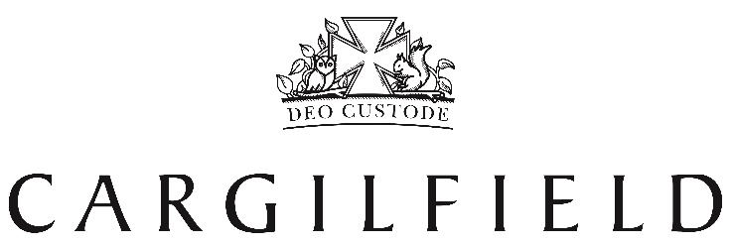

Boarding Weekend Schedule
Autumn Term 2018

Form 8 Leadership Weekend
Friday 31st August – Sunday 2nd September

Form 6 Camp to Ford Castle, Northumberland
Friday 14th – Sunday 16th September

Form 7 France Trip to La Grand Ferme,, normandie
Friday 21st – Monday 24th September

Form 5 Boarding Weekend
Friday 28th – Sunday 30th September

All In Boarding Weekend – Enchanted Forest
Friday 12th October – Sunday 14th October

All In Boarding Weekend – Guy Fawkes & Scotland vs. fiji
Friday 9th – Sunday 11th November

All In Christmas Extravaganza – Beauty and the Beast
Friday 30th November – Sunday 2nd December

