Coronavirus Policy

Coronavirus: Covid 19
Coronaviruses are a large family of viruses which may cause illness in animals or humans. In humans, several coronaviruses are known to cause respiratory infections ranging from the common cold to more severe diseases such as Severe Acute Respiratory Syndrome (SARS).
The most recently discovered coronavirus causes coronavirus disease, COVID-19. This new virus and disease were unknown before the outbreak began in Wuhan, China, in December 2019. Symptoms range from mild to moderate illness to pneumonia or severe acute respiratory infection requiring hospital care. COVID-19 was declared a pandemic by the World Health Organisation on 12 March 2020.
Most people (about 80%) recover from the disease without needing hospital treatment. Around 1 out of every 5 people who gets COVID-19 becomes seriously ill and develops difficulty breathing. Older people, and those with underlying medical problems like high blood pressure, heart and lung problems, diabetes, or cancer, are at higher risk of developing serious illness. However, anyone can catch COVID-19 and become seriously ill. People of all ages who experience fever, new cough or loss/change of smell or taste, should seek medical attention. If possible, it is recommended to call the health care provider or facility first, so the patient can be directed to the right clinic (Appendix 1).
How is coronavirus spread?
There are two routes by which COVID-19 can be spread:
• Directly: from close contact with an infected person (within 2 metres) where respiratory secretions can enter the eyes, mouth, nose or airways. This risk increases the longer someone has close contact with an infected person.
• Indirectly: by touching a surface, object or the hand of an infected person that has been contaminated with respiratory secretions and then touching own mouth, nose or eyes. Under most circumstances, the amount of infectious virus on any contaminated surfaces is likely to have decreased significantly by 72 hours.
How can spread be prevented?
A range of public health measures are used in non-health care settings to try and control transmission of SARS-CoV-2. These include physical distancing, improved personal hygiene – regular handwashing and face coverings, and increased environmental cleaning. As part of the gradual relaxation of lockdown measures the Test and Protect programme, which includes contact tracing, is being implemented to allow a sustained reduction in new cases, outbreaks and to reduce transmission.
At Cargilfield we have put measures in place in line with the guidance published by the Scottish Government. These measures include year group ‘bubbles’. The idea is these ‘bubbles’ do not mix. We have added hand washing facilities around the school to promote good hand hygiene. Staff and pupils are welcome to wear face coverings, but these will not be mandatory.
Staff, parents, visitors or children should not go to school if they:
- have developed COVID-19 symptoms or have been diagnosed with COVID-19 or
- are from the same household as someone who has symptoms of COVID-19 or has been diagnosed with COVID-19 or
- have been identified as a close contact of someone with COVID-19.
A close contact (Appendix 2) is someone who has been physically close enough to the confirmed case for a long enough period of time, that they may have had the virus transmitted to them. Close contacts will be informed of this by the Test and Protect contact tracing team.
The local HPT will be notified of any positive case in complex settings (e.g. schools, nurseries) and will be in touch to offer support and advice to the establishment.

Covid-19 Outbreaks
A Covid-19 outbreak is normally defined as two linked cases of a disease within a specific setting over a period of 14 days.
The objective for staff is to minimise the spread of infection. The NHS and the Scottish Council of Independent Schools (SCIS) have put together toolkits for school to use for possible cases of Covid-19. Information is included on how the response to a suspected or actual Coronavirus outbreak should be managed and the support available.
The Health Protection Team (HPT) at NHS Lothian will be involved in providing advice and support to Head Teachers and Establishment Managers during an outbreak or a single case.

What to do if someone develops symptoms
Child feels unwell with symptoms of COVID-19:
Child unwell with other respiratory symptoms e.g. runny nose, sore throat, sneezing. Then:
- Follow usual policy for sickness at school (stay home at least 48hrs & until fully recovered and free of fever for 48hrs)
- No need for COVID testing unless develops symptoms of COVID-19
- Ensure good hand & respiratory hygiene
.

Child feels unwell with symptoms of COVID-19
- New continuous cough and/or
- Fever/high temperature and/or
- Loss of, or change in, sense of smell or taste.
Immediate area (e.g. desk) occupied by child is cleaned with detergent and disinfectant using appropriate PPE
Double bag any cleaning waste and PPE and store securely for 72 hours before disposal.

Child can return to school provided they are well enough and have not had a fever for 48 hours. The negative test result should be shown to the school.
If the child is not well enough to return to school then the normal procedure for illness should be followed.
Child must isolate for 10 days.
Household must isolate for 14 days
School should inform the HPT as soon as possible.
School arranges deep cleaning of affected areas.

Parents/carers contacted and asked to collect child as soon as possible.
Parents/carers arrange a test for the child online at www.nhsinform.scot or call 0800 028 2816.
Child and household should remain isolating at home while waiting for the test result.
Parent/carer should notify the school of the result when they receive it
Child is removed from contact with others and isolated somewhere safe and at least 2 metres away from other people. Staff looking after the child should wear gloves, apron and a fluid resistant surgical mask.

Positive result Negative result
Staff member feels unwell with symptoms of COVID-19:
The Test and Protect contact tracing team will be in touch to identify any potential close contacts.
The HPT will be informed of the result and will contact the school to follow up school contacts and to provide further advice.

Staff member feels unwell with symptoms of COVID-19
- New continuous cough and/or
- Fever/high temperature and/or
- Loss of, or change in, sense of smell or taste.
If at work, staff member goes home as soon as possible.
- Minimise contact with others
- Wear face covering on public transport
If at home, staff member must remain at home and follow school’s absence procedures.
Staff member arranges a test online at www.nhsinform.scot or by calling 0800 028 2816.
Alternatively, the staff member can be referred for testing via the Employer portal.
Staff member and household should remain isolating at home while waiting for the test result.
Immediate area (e.g. desk) occupied by staff member is cleaned with detergent and disinfectant using appropriate PPE.
Double bag any cleaning waste and PPE and store securely for 72 hours before disposal.

Positive result
Negative result
Staff member must isolate for 10 days.
Household must isolate for 14 days
School should inform the HPT as soon as possible
School arranges deep cleaning of affected areas.

Staff member can return to work provided they are well enough and have not had a fever for 48 hours.
The negative test result should be shown to the school.

Really useful documents.

The Test and Protect contact tracing team will be in touch with the staff member to identify any potential contacts.
The HPT will be informed of the result and will contact the school to follow up school contacts and to provide further advice.

RESOURCES
(Above document adapted from various resources listed below)

Coronavirus (COVID-19): guidance on preparing for the start of the new school term in August 2020
https://www.gov.scot/publications/coronavirus-covid-19-guidance-preparing-start-new-school-term-august-2020/
COVID-19 – guidance for non-healthcare settings
https://www.hps.scot.nhs.uk/web-resources-container/covid-19-guidance-for-non-healthcare-settings/
Coronavirus (COVID-19): getting tested in Scotland
https://www.gov.scot/publications/coronavirus-covid-19-getting-tested/pages/arrange-a-test/
SCIS- Coronavirus Guidance for Schools
http://www.scis.org.uk/about-scis/coronavirus-covid-19-guidance-for-schools
World Health Organisation- Q&A on coronaviruses (COVID-19)
https://www.who.int/emergencies/diseases/novel-coronavirus-2019/question-and-answers-hub/q-a-detail/q-a-coronaviruses
NHS Lothian
https://www.nhslothian.scot/Coronavirus/Pages/default.aspx
NHS Inform
https://www.nhsinform.scot/coronavirus
Parent Club – referral flowchart
https://www.parentclub.scot/sites/default/files/inline-images/flowchart-web-V5.jpg

Appendix 1- ‘When should I book a test for my child?’

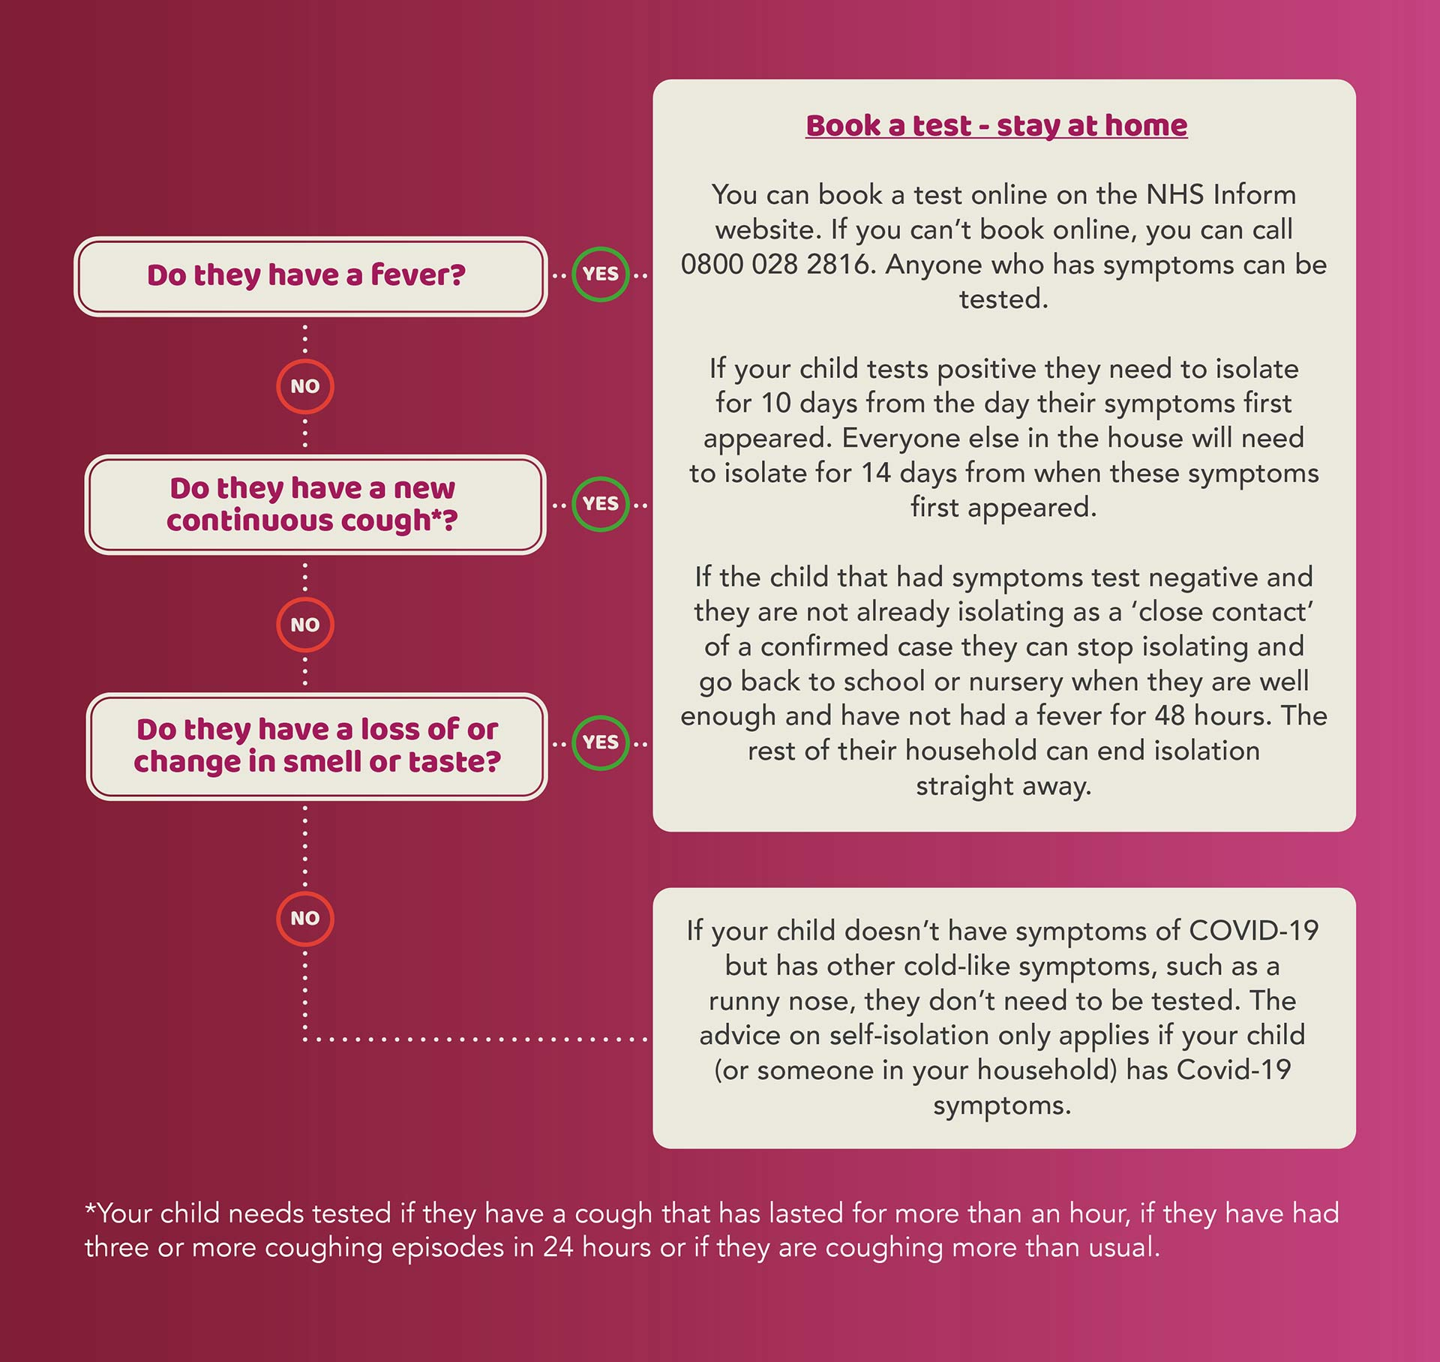

Appendix 2- Close Contact

What do we mean by a ‘contact’ with regards to COVID-19?
A ‘contact’ is a person who has been close to someone who has tested positive for COVID-19 anytime from 2 days before the person was symptomatic up to 10 days from onset of symptoms (this is when they are infectious to others). For example, a contact can be:
• people who spend significant time in the same household as a person who has tested positive for COVID-19
• sexual partners
• a person who has had face-to-face contact (within one metre), with someone who has tested positive for COVID-19
• a person who has been within 2 metres of someone who has tested positive for COVID-19 for more than 15 minutes
• a person who has travelled in a small vehicle with someone who has tested positive for COVID-19 or in a large vehicle or plane near someone who has tested positive for COVID-19
Copied from: https://www.gov.uk/government/publications/guidance-for-contacts-of-people-with-possible-or-confirmed-coronavirus-covid-19-infection-who-do-not-live-with-the-person/guidance-for-contacts-of-people-with-possible-or-confirmed-coronavirus-covid-19-infection-who-do-not-live-with-the-person#:~:text=A%20'contact'%20is,positive%20for%20COVID%2D19

Complied by L. MacGregor (School Nurse) August 2020

