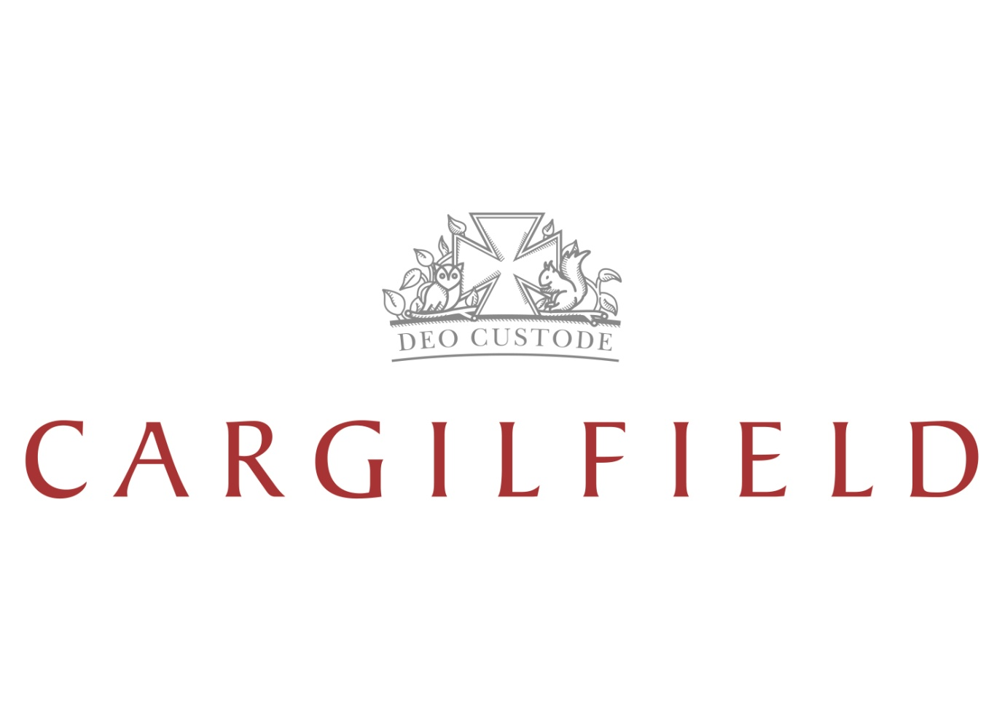

**Monday**

Chilli tacos

Sweet potato Tikka Masala with basmati rice

Rice

Garden peas

Selection of salads

Baked jacket potato with selection of fillings

Apple crumble with custard omemade H

**Tuesday**

Roast gammon

Falafel wraps with tomato jam, hummus and spinach leaves

Roast potatoes

Broccoli

Carrots

Selection of salads

Baked jacket potato with selection of fillings

Waffles & Chocolate sauce

**Wednesday**

Chicken Kiev with garlic butter

Homemade Vegetable Kiev

Herby Potatoes

Green beans

Selection of salads

Baked jacket potato with selection of fillings

Lemon drizzle cake

**Thursday**

Mini Sausage & Onion gravy

Roast squash and potato tagine with lemon cous cous

Yorkshire puddings

Baby potatoes

Green beans

Selection of salads

Baked jacket potatoes with selection of fillings

Strawberry mousse

**Friday**

Beef & Broccoli stir fry

With prawn Crackers

Vegetable stir fry

Selection of salads

Baked jacket potato

With selection of fillings

Eton mess

**Menu**