Support for Learning Policy

Cargilfield is committed to meeting the needs of all pupils, including those with additional support needs where reasonable adjustments within the scope of the School’s available resources are possible.

Aims
The Support for Learning department encourages and promotes learning and achievement through
- Supporting all pupils in an inclusive and as individual a manner as possible.
- Effective lines of communication with staff and parents of children with additional support for learning needs.
The support for learning department policy is set out in the following objectives which are in line with the Education (Additional support for Learning) (Scotland) Act 2004 and 2009, Education (Additional support for Learning) (Scotland) Act 2004 and 2010 Code of Practice, the Equality Act 2010 and the City of Edinburgh Council In on the Act, guidance for staff.

Staff within the support for learning department work with pupils who have additional support needs (ASN), staff, parents and outside agencies to anticipate and meet learners’ needs in the following ways.
Pupils
- To support learning and enable learners to be achieve their full potential in the goals they and the School have set and access the best senior school for them.
- To encourage learners’ self-confidence and self-esteem.
- To ensure learners’ expectations are realistic and to increase their motivation
- To ensure ongoing monitoring and evaluation of progress of individual learning outcomes
- To ensure access to an appropriate curriculum.

Staff
- To ensure that appropriate provision is made in all necessary subject areas for those with additional support needs.
- To develop the expertise and skills of teaching and support staff in the area of additional support needs.
- To operate within the whole school as a resource to support pupils’ learning.
- To offer advice and support.

Parents
- To ensure ongoing partnership with parents through collaborative working and to offer advice and support.
- To guide and advise the parents’ support Group

Outside Agencies
- To organise the involvement of outside agencies where necessary.
- To work collaboratively with outside agencies to meet the needs of individual learners.
The Roles of the Support for Learning Teacher

There are four members of teaching staff in the Support for Learning Department. Emma Buchanan (Head of Department and full time), Nicola Lyell (Upper School and part time), Fiona Macmillan (Upper School and part time), Maggie Pithie (Pre-prep and part time)

1 Consultation

Consultation between SfL and teachers may occur formally or informally as the needs arise. This will include highlighting concerns which may led to a formal referral, discussing teaching approaches, learning styles, differentiation approaches and resources to support children within the classroom. This should be sufficient to meet the needs of most pupils with ASN.

Co-operative teaching
Cooperative teaching between the class/subject teacher and the SfL teacher takes place in literacy/English and maths and also in other subjects by agreement. This allows pupils with ASN to gain full access to the curriculum within the classroom setting. It also provides the opportunity to provide support for all pupils within a classroom.

The Class/subject teacher and SfL teacher will agree the targets and learning outcomes of the sessions, decide on the appropriate teaching/learning strategies and plan activities to meet the needs of those requiring support.

Direct Teaching
In consultation with teachers and parents, an individual or small group of pupils may be withdrawn from class for targeted input for their specific difficulties.

- Liaison
The SfL teacher will liaise with parents and outside agencies including Psychological Services, Speech Therapy, Occupational Therapy and medical professionals

- Staff Development
The Support for Learning department works with staff to ensure they are fully aware of their responsibilities in identifying and supporting pupils with ASN. SfL staff provide, both formally and informally, details of pupils with ASN and information on strategies and teaching approaches. A comprehensive list of children with ASN is kept constantly updated by SfL staff and is available to all staff in the planning folder in the staff area of the network along with information on specific learning difficulties and suggestions for techniques and approaches for supporting successful teaching and learning in the classroom.

- Examinations
The School follows the JCQ guidelines with regard to individual access arrangements for examinations. Pupils with ASN do not automatically qualify for these but those who do, may for example, be granted additional time, a prompter or be permitted to use a word processor or bilingual dictionary. Pupils who qualify will be given the opportunity to use these arrangements in F7 and 8 and in exceptional circumstances F6.

SfL staff will assist subject teachers in modifying examination papers where appropriate. They also have the responsibility for arranging the individual access arrangements in consultation with relevant staff. The information required by the ISEB is submitted at the relevant time and in consultation with the Headmaster, Director of Studies and future schools.

Additional Support Needs : Identification and Assessment

In order to ensure that teaching meets the needs of each learner the aim is to identify any ASN at the earliest possible stage, thereby preventing or minimising any barriers to learning that may be experienced.

The teaching of all pupils is the responsibility of the class/subject teacher. They have a responsibility to make reasonable adjustments and apply appropriate differentiation strategies. SfL staff will provide support and advice with this if required.

A formal referral to the SfL department (see Appendix 1) is made when:
- There is concern, underpinned by evidence, about a pupil who is not progressing as expected even when teaching is targeted to a pupil’s identified areas of weakness.
- There are signs of difficulty in literacy or numeracy skills resulting in poor attainment in learning.
- Communication or social interaction difficulties, sensory, physical or behavioural difficulties.
- There are potential mental health concerns.

Referral to Learning Support

Initial discussion between class teacher (Pre-prep/F4), subject teacher and SfL teacher

An official referral form
is completed by Class or subject teacher and SfL teacher and Head of SfL informed

The class teacher will talk to the parents (Pre-Prep/F4)
The SfL team will coordinate the informing of parents (Upper School)

Assessment takes place (if appropriate)

A meeting is held with parents, class teacher (Pre-Prep/F4) and relevant subject teachers to discuss results and agree subsequent actions (if appropriate)

The pupil’s details will be added to the ASN list. The need for a summary IEP will be considered

When a pupil is officially referred the SfL staff will commence the process of assessment. This will include observation, a review of performance in tests and exams, liaison with teachers and parents and, if necessary, testing to determine the areas of strength and areas which may require extra support. This will be discussed with the pupil as and when appropriate.

The findings of the assessments will be discussed with relevant staff and parents. The results may indicate the need for further investigation. In some cases the pupil may, with the agreement of parents, be referred for assessment by an educational psychologist, the cost of which is borne by the parents.

When appropriate SfL staff will suggest parents seek a referral through their GP to a different specialist, such as an optometrist, audiologist, occupational therapist, speech therapist, paediatrician, counsellor or CAMHS.

Diagnostic assessment is undertaken by SfL if deemed necessary and the tests used include:
- York Assessment of Reading for Comprehension.
- Dyslexia Screening Test
- Phonological Awareness Battery
- Listening and Literacy Index
- Aston Index
- Single word spelling Test (SWST)

Provision of Support for ASN

Effective provision of support for learning is essential if pupils are to achieve their full potential. The steps taken by the School to provide this are based on the GIRFEC Model of Staged Intervention (see below).

Step 1: The pupil needs greater than normal teacher support in one or more curricular areas. Through normal classroom assessment and evaluation procedures the teacher will implement appropriate differentiation strategies which will usually involve some adjustment to the class programme and the teaching and learning techniques employed. The subject teacher will inform the SfL staff and keep them updated about progress over a defined period of time. Parents will also be informed by the subject teacher as to the concerns and the measures which have been put in place.

Step 2: Level 1/Stage 1: If the pupil continues to encounter difficulties despite the interventions which have been put in place in step 1 a formal referral will be made to the SfL department using the pupil referral form (See Appendix 1). The formal diagnostic assessment process will be carried out. Following this the subject teacher/s and SfL staff will plan an appropriate course of action which may include specific assistance being given to the pupil by the SfL department. Parents will be consulted and kept regularly up to date. An Individual Education Programme (IEP) will be considered.

Step 3: Level 2/Stage2: If the pupil continues to experience difficulties and requires significant support then in consultation with the Headmaster and with parents’ permission a referral will be made to an educational psychologist by the SfL dept. Following a visit to the school an assessment of the pupil and a meeting with parents, a written report will be provided with advice where appropriate on the content of the curriculum and learning and teaching strategies. At this stage an IEP will be put in place by the SfL department. An Assessment of Need will also be completed if deemed necessary.

Step 4: Level 3/Stage 3: If the difficulties a pupil is encountering cannot be addressed and resolved by the School or by an educational psychologist then in consultation with the Headmaster and with the agreement of parents advice and support will be sought from agencies out with education following a formal assessment of need. Although children within the independent sector are not legally eligible for a coordinated support plan it may be considered at this point.

GIRFEC Model of Staged Intervention

The model of staged intervention below sets out three levels of staged intervention and the links with the GIRFEC approach and planning tools. As with all staged intervention processes movement between stages is usually following exhaustion of the provisions at the level below. In some cases acceleration through the stages will be required to meet the individual needs of a pupil. This process enables those taking decisions about support to ensure that the support proposed is appropriate.

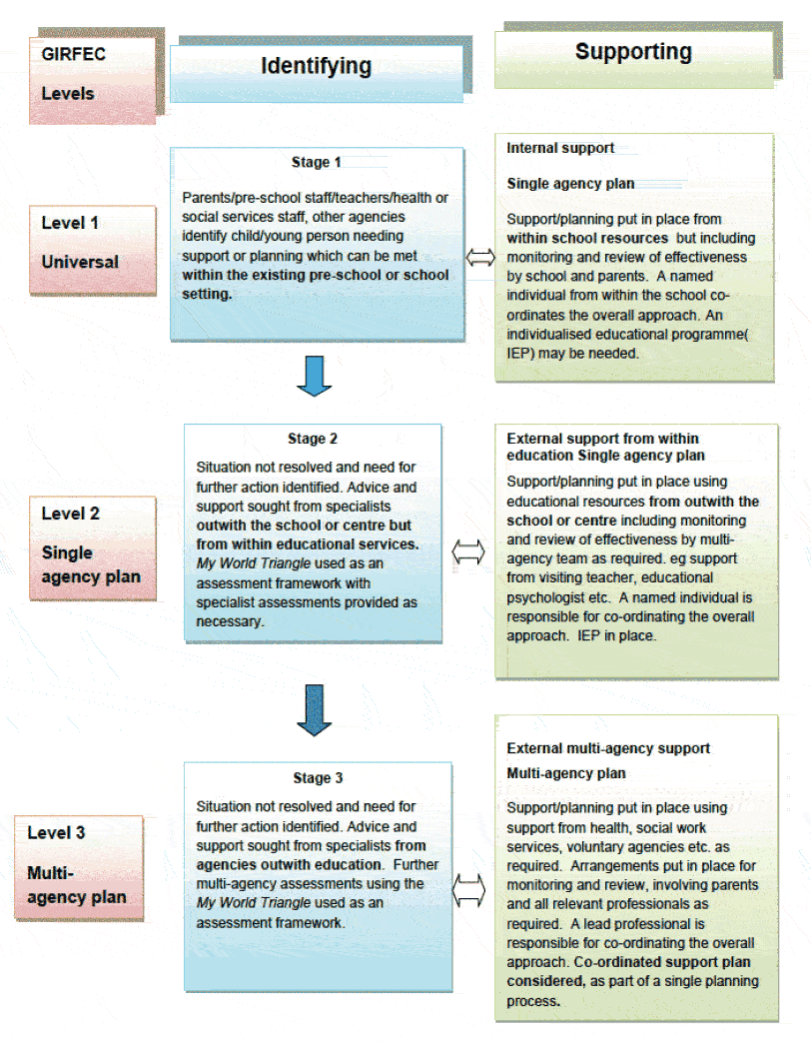
The Support for Learning Shared Area
The All Staff section Support for Learning folder in the Staff Shared Area is where we store all the relevant information is stored. This includes the ASN list, Differentiation advice, the SfL Policy, Pupil Files, Referrals, Revision and Testing.

Individual Education Plans

An Individual Education Plan (IEP) is a written plan which provides a framework which underpins the teaching and learning approaches by which a pupil’s ASN will be best met. These will vary in nature depending on the nature of the ASN. The SfL dept. is responsible for completing and keeping pupil IEPs up to date. A summary (Appendix 2) is provided to staff to assist with their curriculum planning, pastoral care and ongoing monitoring of health and wellbeing. This is sent by email and is also stored in the planning folder in the staff area of the network. The IEP is reviewed and updated on an ongoing basis as required.

Schemes of Work
Plans are reviewed and revised on a termly basis, and often more frequently, for those pupils who receive direct teaching from the SfL dept. These will vary from term to term building on what has been previously taught and learned and frequently revisiting areas for consolidation and reinforcement. A set planning sheet is used (see Appendix 3).

Reporting
Good communication between home and school is considered essential to ensure the needs of pupils are fully met.

Reporting to parents
Full written reports are provided for parents in the autumn (US only) and summer terms. SfL staff meet parents at the parent/teacher meetings which are spread throughout the year. In addition to this, Upper School SfL staff meet parents in the spring term.

SfL staff keep in close touch with parents at all times through email and informal meetings/conversations.

Reporting to Senior Schools
Before Common entrance is taken, SfL staff inform the senior school of the nature of support given and of any special arrangements in place for the examinations.

Admissions and Ongoing Pupil Tracking

Pupils wishing to join the school, from Nursery to F8, undergo an assessment carried out by SfL staff and reports are sought from the current Nursery or School. The offer of a place is largely, but not completely, determined by the information provided by these.

From entry into Cargilfield children’s progress is tracked and monitored both formally and informally. The SfL dept. are responsible for the ongoing formal tracking of pupil progress.

- The PIPS P1 baseline assessment is carried out at the start of the year (from 2017-18) and a follow up assessment is carried out at the end of the year. Those who present with difficulties in the acquisition of early literacy and numeracy skills are flagged up and monitored carefully by the class/subject teacher and SfL staff.

- INCAS standardised testing is used in P3 (spring), F5 (autumn), F6 (summer).

- The Single Word Spelling Test is carried out annually from P2 to F7.

Results of all standardised tests are tracked from year to year and shared and evaluated with the Headmaster, class/subject teachers and SfL staff and further action taken if appropriate. Results are stored in the staff area of the network under screening test results.

Learning Support Department
Pupil Referral Form
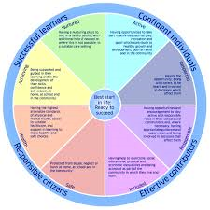
The 5 Questions
To measure and assess any need, professional working with children need to ask themselves the following 5 questions in terms of the wellbeing indicators:
1. What is getting in the way of this child’s wellbeing?
2. Do I have all the information I need to help this child?
3. What can I do now to help this child?
4. What can my service do to help this child?
5. What additional help, if any, may be needed from others?

Please tick appropriate section(s)
Name of Pupil:
Date of Birth
Form:

- Details of Concern (evidence to support concern must be attached):

- Differentiation Strategies applied so far:

- Parental consent for initial assessment received by Pre-Prep Form Teacher: Yes/No Date:
Parental consent for initial assessment received by Upper School LS Teacher:
Yes/No Date:

Referrers Signature:
LS Teacher Signature:

Initial Assessment carried out:
1. Date:
2. Date:

Appendix 1

Individual Education Plan Summary
Name: D.O.B Class: GIRFEC Level of Need:
Professional’s involved:
Current Date: Date of Next Review:
Key concerns arising from Assessment:

Strengths:

Support Strategies:

Appendix 2
Direct Teaching Subject
Teacher: Pupil(s):
Form: Date:
Learning Intentions | Teaching and learning Strategies/Activities | Resources | Success Criteria
Appendix 3

