What We Learn Through Play

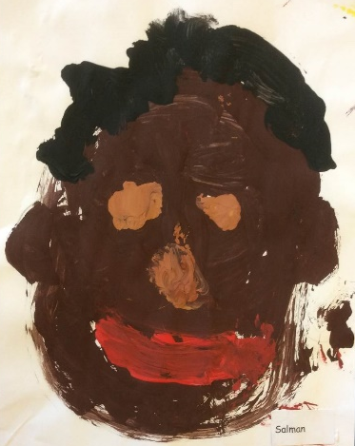

CONSTRUCTION

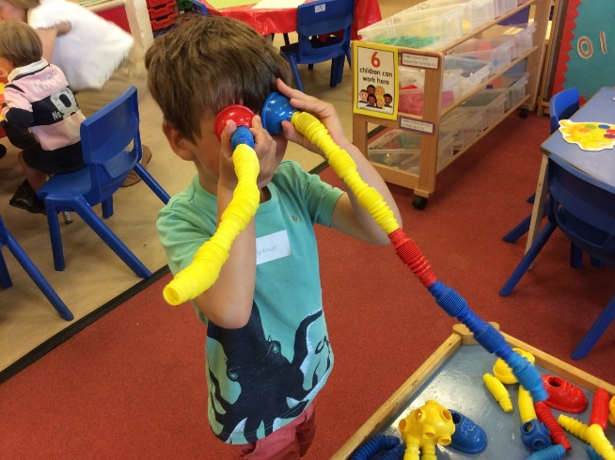

Construction play occurs when a child uses their imagination and skills to create a product. A child can put on a performance, learn problem solving skills, or build sentences. For example, artwork, magic shows and building space rockets all involve constructive play. This type of play is important for obvious reasons. It develops problem solving skills, imagination, fine motor skills, and self-esteem.

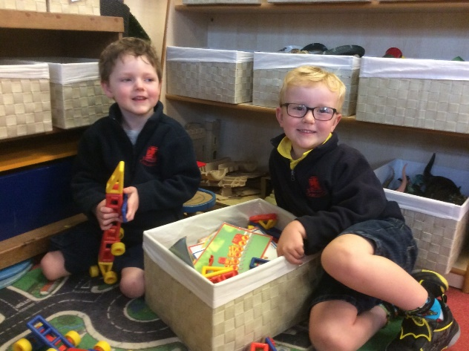

FINE MOTOR DEVELOPMENT

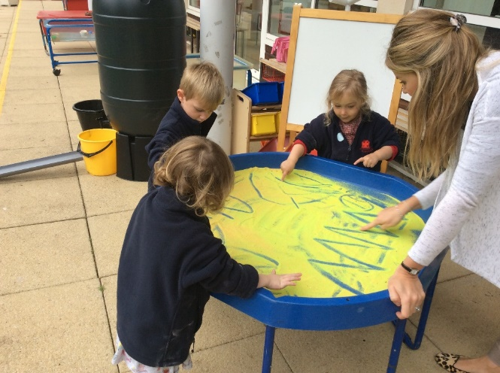

Fine motor skills are activities that require the use of the small muscles in the hand. These activities include grasping small objects like beads, holding a pencil correctly, cutting and buttoning. It is easy to see how critical fine motor skills are to every area of a child's life. Fine motor skills can directly affect a child's self-esteem and success at school.

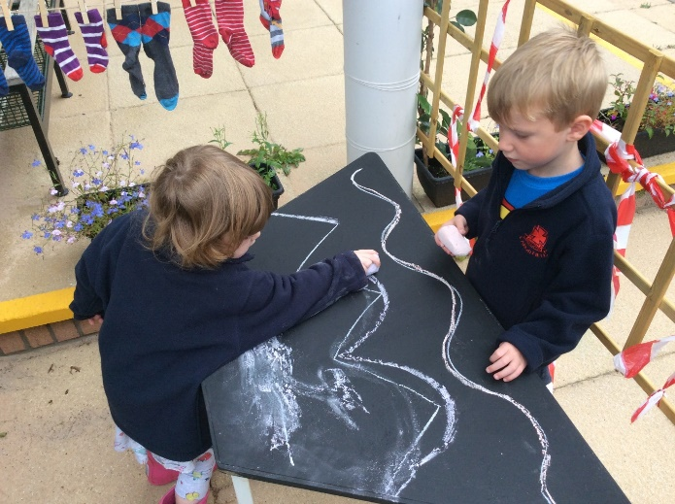

CREATIVITY

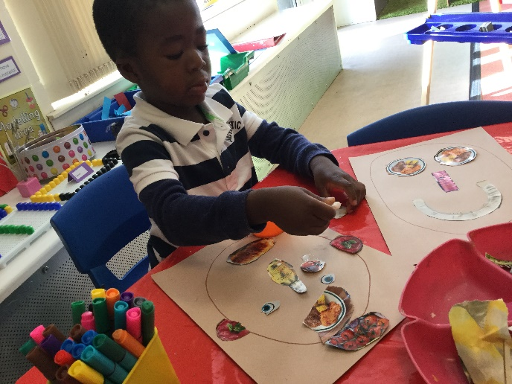

Art is important for children especially during their early development. Research shows that art activities develop brain capacity in early childhood. Art engages children's senses in open-ended play and develops cognitive, social-emotional and multi-sensory skills.

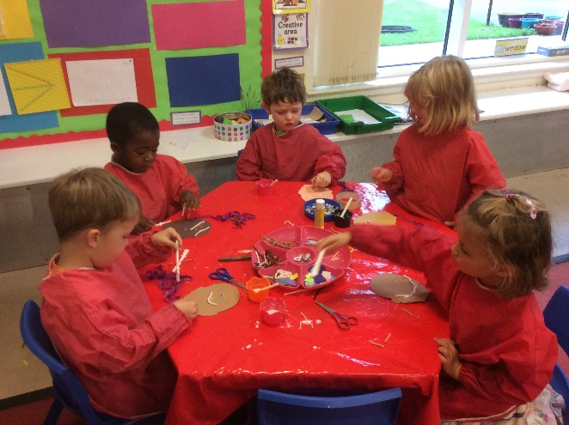

SAND PLAY

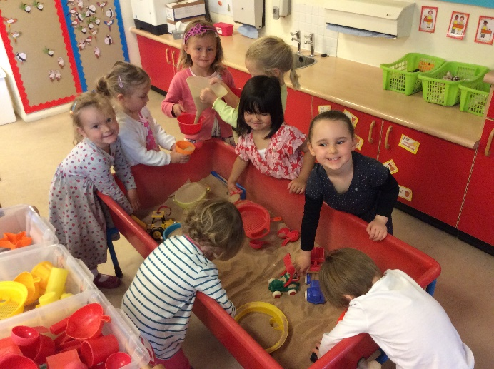

There is no right way to use sand. It invites participation, permits children to make and test hypotheses, stretches the imagination, provides a potentially soothing sensory experience and it is an excellent avenue for children to learn physical, cognitive and social skills.
Because sand play is open-ended, the child determines the direction and path of his or her own play. This freedom then clears the way for the child to build developmental concepts.

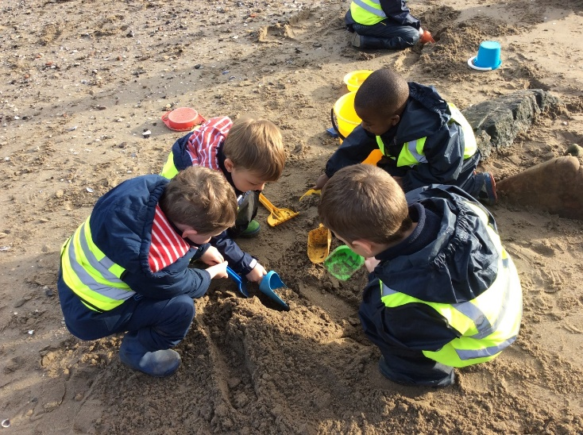

GARDEN AREA

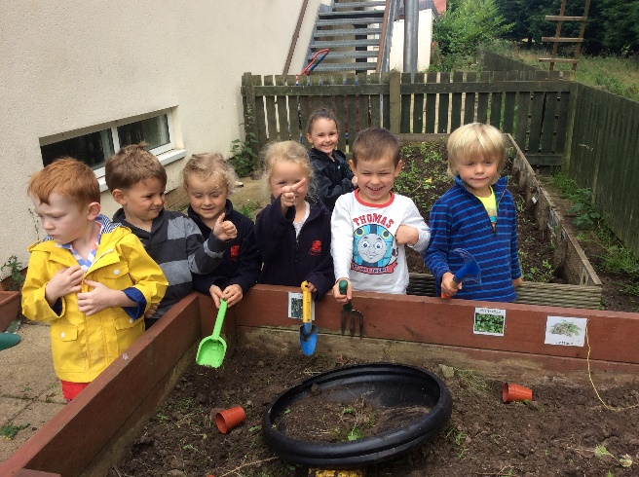

Gardening is a wonderful way for children to discover, explore and learn. The beauty of gardening in Nursery is that you can involve children in every step of the way. The whole process of gardening is easily woven into the fabric of a Nursery day. It is an extended sensory and learning process which could start with researching the right plants to grow, preparing the soil, digging and planting, watering, weeding and observing the plants growing and flowering.

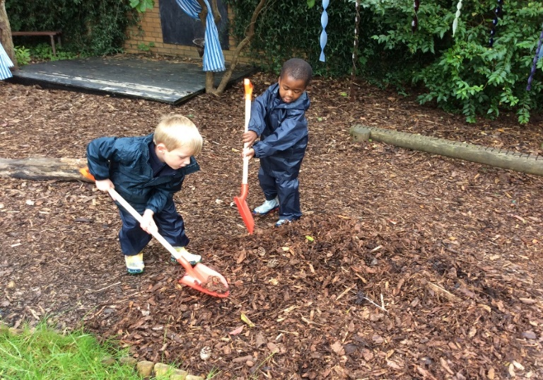

ROLE PLAY

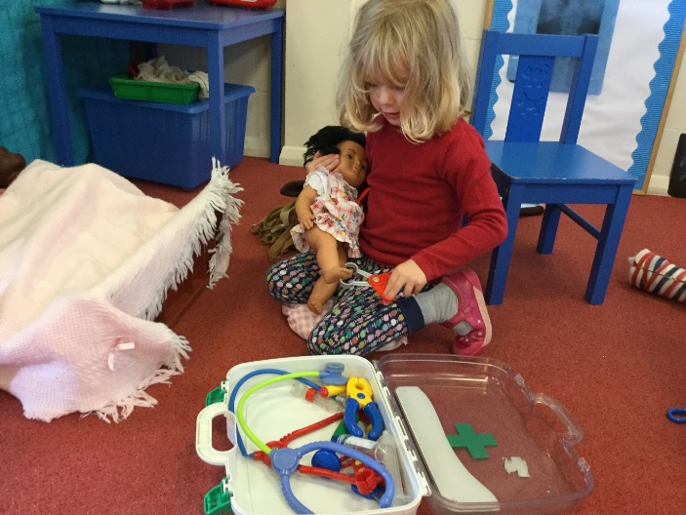

Pretend play requires the ability to transform objects and actions symbolically. It is further enhanced by interactive social dialogue and negotiation and it involves role taking, script knowledge, and improvisation. Many cognitive strategies are exhibited during pretence, such as joint planning, negotiation, problem solving and goal seeking. Symbolic competence is also of great importance as it helps children make connections with objects and symbols to assist with reading and writing.

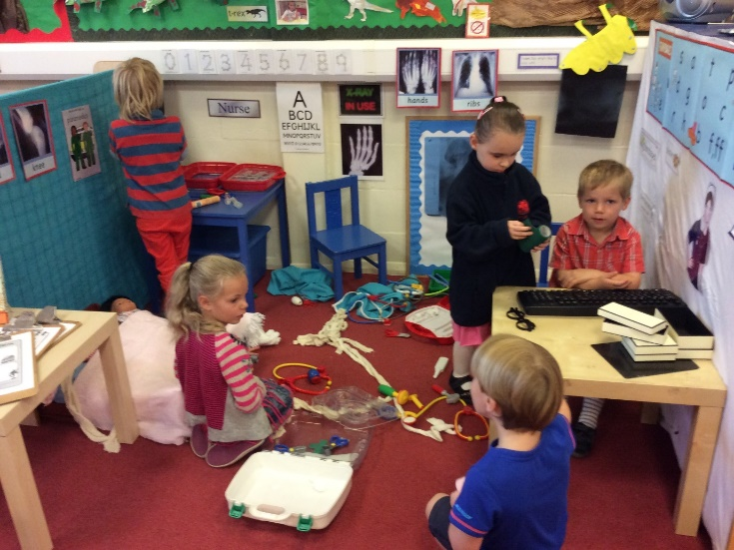

MUSIC

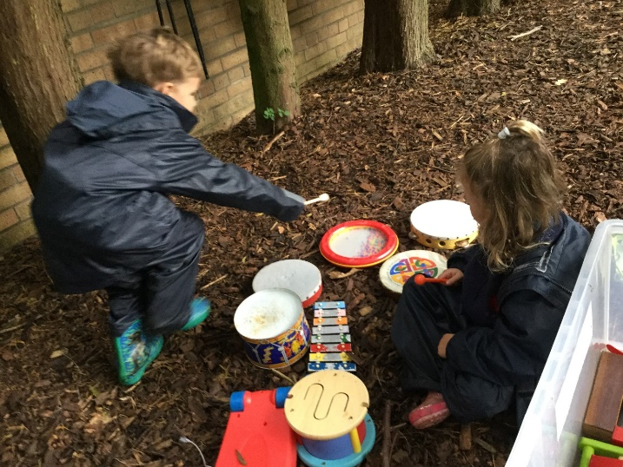

Music through play develops multi-sensory, cognitive and social-emotional skills. Making and playing instruments, singing, and dancing allows children to learn language, make connections to familiar experiences and form communities. Research has shown that children who are regularly and actively involved with music are better able to focus and control their bodies, play better with others, and have higher self-esteem.

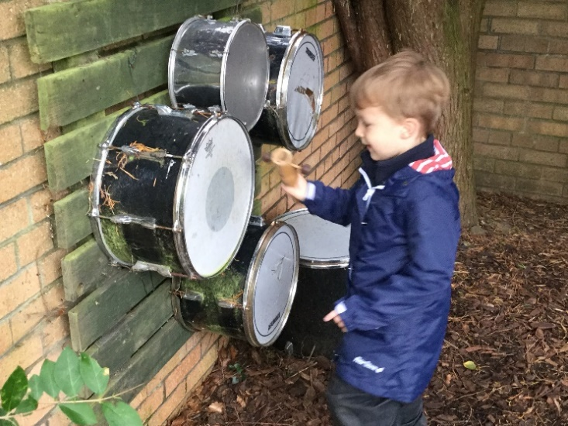

WATER PLAY

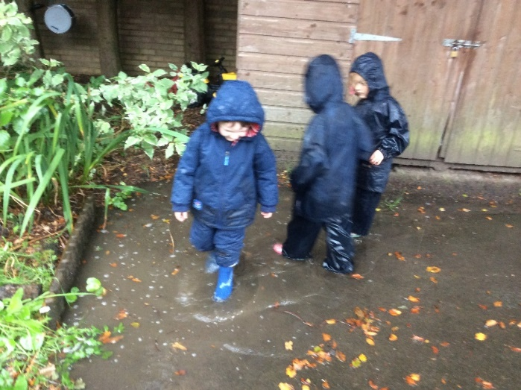

Water play delights the senses and is far more than simply pleasurable for young children. This type of sensory play is important for the development of the young child. Water play is good for children's physical, mental (cognitive) and social-emotional growth. It helps them to improve their physical dexterity and eye-hand coordination. By playing with others they develop social skills. At the same time, they use their mind as they explore why certain objects sink in water and others float. Children learn mathematical concepts such as empty/full, before/after, shallow/deep and heavy/light in a hands on way.

CREATIVE DRAMA

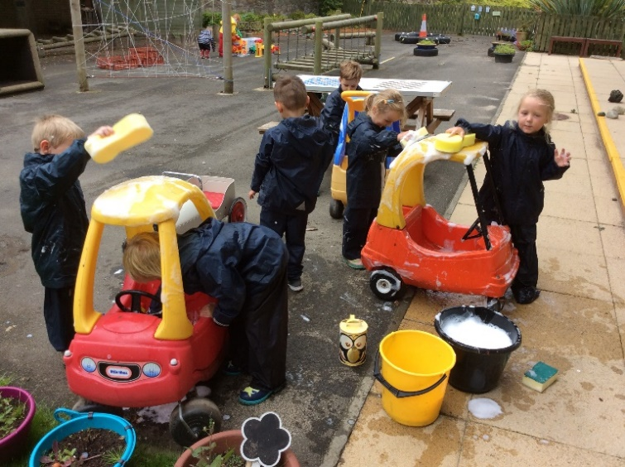

Through dramatic play children explore social roles and expectations. Concepts of community and culture develop as children take on characters in play and learn empathy and understanding as they step into another's shoes.

In this symbolic play, children use the same thinking skills that will later help them to recognise words as symbols for describing their experiences. Children build literacy skills as they 'write' shopping lists and 'read' bedtime stories to baby dolls.

Playing in the 'house' children practice gross motor skills, balancing in dress up shoes and negotiating the slope of the slide. Small motor skills are practiced when dressing dolls, operating the cash register and holding small resources.

CREATIVE CONSTRUCTION

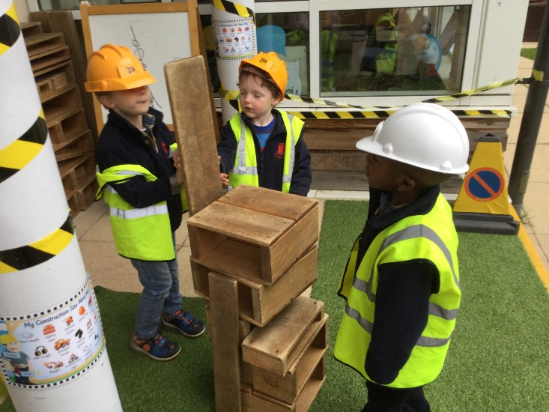

With a large variety of open-ended materials children discover the relationships between objects, how they are alike and different and how they go together. Exploring physical attributes, children gain an understanding of size, measurement and patterns. Children experiment with balance, force and weight. Concepts of more and less, part and whole, and simple addition and subtraction are discovered through construction play.

Children use both natural materials and man-made objects in their building and the use of simple technology, ramps, wheels and axels extends the depth of their construction project.

Through construction play, children practice creative problem solving and engage in symbolic representation.

RESPONSIVE PLAY

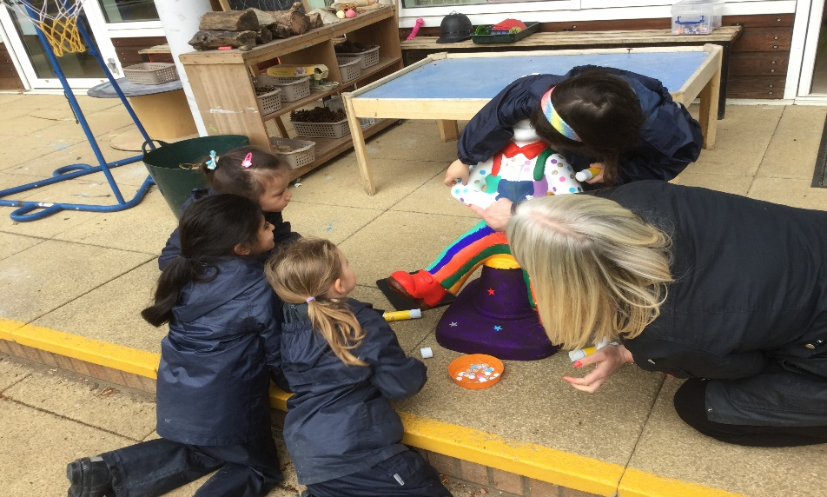

Responsive play is an approach to conversation and play that is meant to help promote positive interactions between adults and children. Adults join in play and follow the child’s lead, while promoting turn-taking in conversation and play. When being responsive during play adults interpret child behaviours as an intent to communicate and respond to these behaviours as a way to reinforce child initiations and communication attempts. There are several strategies to use during responsive play.

Imitating language: Imitation involves repeating what a child says. For example, if the child picks up a toy train and says, “train”, the adult could point at the train and say, “train.”
Expanding language: Expanding involves repeating what the child says and adding an extra component. For example, if the child says “train”, the adult could say “red train.”
Imitating play: Imitation in play involves doing exactly what the child does.
Expanding play: Expansion in play involves doing what the child does and adding an extra behavior. For example, if the child holds a baby, the adult could hold a baby and feed the baby with a bottle.
Following a child’s lead: During play, allow the child to take lead and follow what they do. If they change toys, change toys with them instead of trying to re-engage them with the previous toy.

